Andre Miranda
SNHU

CS-319

Professor Jill Platts

09/26/2025

Project One
Digital Wireframe:
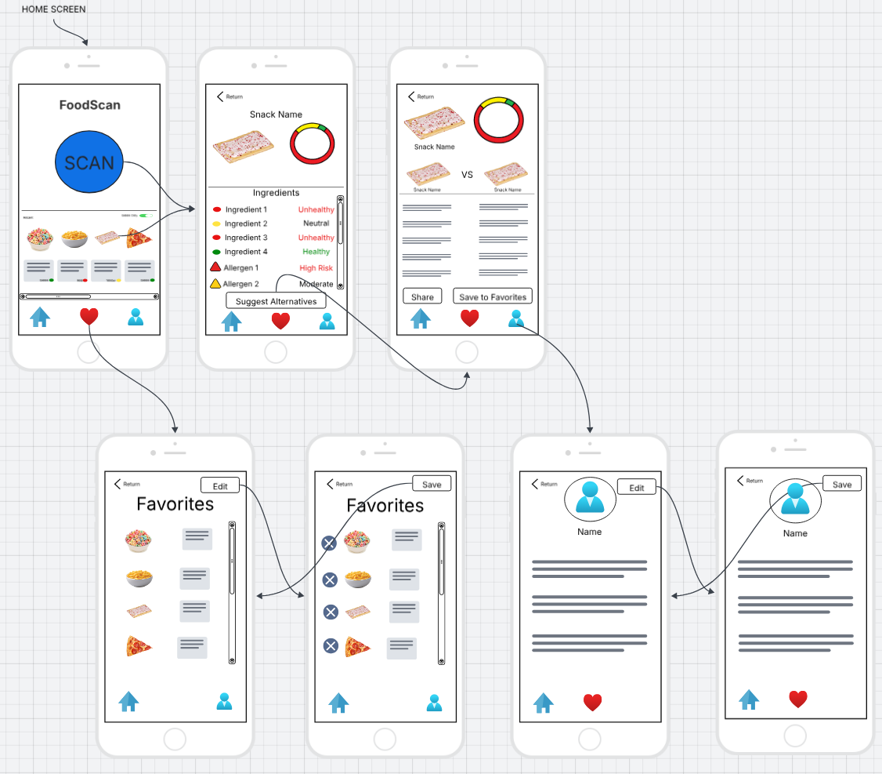

Client Communication and Recommendations:
Designing FoodScan, a mobile application focused on real-time ingredient transparency, required a user-centered approach. I needed to make sure the design is based on research, accessibility, and platform-specific best practices. The app’s primary goal is to help users make informed, health-conscious decisions while shopping for food by scanning product barcodes and instantly visualizing the health impact of ingredients. Now let us look at some of the screens in the wireframe, so that I can explain how the design benefits users, and explore adaptations for digital watches and touch-based kiosks.
The FoodScan wireframe consists of five core screens, which include a Home and Scan Scree, an Ingredient Breakdown screen, Alternative Suggestions and share/save to favorites screen, a Favorites screen, and a Profile screen. Each screen was designed to serve a specific function while still maintaining a consistent visual language. The Home/Scan screen acts as the app’s launchpad, featuring a large central blue “Scan” button for immediate action. Below the button, users can scroll horizontally through recently scanned items, with a toggle filter that allows them to view either “Green Only” (healthier items) or “All.” A bottom navigation area includes Home, Favorites, and Profile icons, ensuring users can easily access key features. This layout can accommodate both low-tech users who prioritize simplicity and high-tech users who seek more granular control.
The Ingredient Breakdown screen is triggered after a scan or by clicking on one of the recently scanned items. It displays the product name and image at the top, along with a circular health score ring divided into a red section, yellow section, and green section to indicate the overall health impact. Each ingredient is listed with a color-coded tag on the left, a brief description, and a score of either unhealthy, neutral, or healthy for ingredients and high risk or moderate for allergens and additives. Triangle icons are used to bring user’s attention to allergens and additives for each of the items. At the bottom of this screen, you see a “Suggest Alternative” button which allows users to explore cleaner options. This screen was designed for those who want to quickly assess snacks and avoid harmful ingredients including but not limited to parents, fitness enthusiasts, and health-oriented people.
The Alternative Suggestions and share/save to favorites screen presents a recommended healthier product next to the original item including product images, names, and ingredients list similar but more compact when compared to the ingredient breakdown screen. This screen also has buttons to save the item to Favorites or share it with others. This screen accommodates users who track macros, manage dietary goals, or enjoy sharing clean options with friends. The Favorites screen provides a personalized archive of saved products, enabling users to revisit clean choices and organize them by category, while the Profile screen allows users to manage dietary preferences, user information, privacy/security options, and adjust settings, ensuring the app remains relevant and personalized for each user.
Each design decision was built upon my analysis and user research. The app draws inspiration from similar apps like Yuka and FactsScan which are existing food analysis apps. Yuka’s intuitive UX and color-coded scoring system influenced FoodScan’s visual simplicity and scan flow. FactsScan’s granular ingredient breakdown and alert system was the groundwork for the detailed feedback and alternative suggestions screens. User personas, including parents, health-conscious individuals, and accessibility-focused users, helped me design the convenient layout and features. By adhering to Android and Apple design guidelines, FoodScan ensures compliance with touch targets, contrast ratios, and navigation standards.
To extend FoodScan’s functionality across platforms, the wireframe can be adapted for digital watches using Wear OS best practices. On a smartwatch, priority content must be glanceable and time saving. The Home and Scan screen would be reduced to a scrolling and single tap interface, allowing users to jump into previously scanned items from their wrist. The circular health score ring and alert icons would be displayed as swipeable cards, enabling users to quickly assess product health. Voice commands and haptic feedback would enhance accessibility, while favorite edits could synchronize with the mobile app for better integration. This adaptation supports users who shop frequently and want instant access to an item list without pulling out their phones.
For touch-based kiosks, the wireframe would be expanded to leverage the larger screen real estate and accommodate group interaction. The Home and Scan screen would feature a full-screen scan interface with large touch targets. Ingredient breakdowns would be displayed in a vertical layout with expandable sections for each ingredient. The Alternative Suggestions and share/save to favorites screen would present side-by-side comparisons in landscape orientation, allowing users to evaluate options clearly. Favorites and Profile features could be accessed via a sidebar or bottom navigation menu. This adaptation is ideal for grocery stores or health food retailers, offering anonymous scanning and educational value for families and friends.
In both adaptations, priority content is preserved, and logical actions are streamlined to match the device’s capabilities. The smartwatch version emphasizes glanceability and speed, while the kiosk version focuses on clarity and interactivity. By following design best practices for wearables and large screens, FoodScan maintains a complete and user-friendly experience across platforms.

